October - December, 1999
SFD
Newsletter
Investment by Sector (4th Quarter/ 1999)
Percentage | Investment ($) | No. of Projects | Sector
35 | 4,273,340 | 76 | Education
6 | 783,406 | 19 | Health
12 | 1,449,259 | 23 | Water
19 | 2,290,631 | 10 | Environmental Activities & Sewerage
5 | 637,648 | 6 | Roads
22 | 2,660,000 | 6 | Social Services
1 | 151,630 | 21 | Capacity Building
100 | 12,245,914 | 161 | Total

Investment by Sector (4th Quarter/ 1999)

Beneficiaries and Job Opportunities:
The following tables show the expected number of beneficiaries and job opportunities created from SFD programs and projects during the fourth quarter of 1999.

Expected Beneficiaries in the Fourth Quarter
Indirect Beneficiaries | Direct Beneficiaries | Group
12,503 | 83,883 | Men
12,901 | 84,426 | Women
14,696 | 107,213 | Boys
12,804 | 96,137 | Girls
52,904 | 371,659 | Total

Expected Direct Beneficiaries in the Fourth Quarter

Expected Job Opportunities Created (4th Quarter/ 99)
Temporary  (person - day) | Permanent  (person) | Group
409,805 | 694 | Male
459 | 484 | Female
410,264 | 1,178 | Total

SFD Accumulated Investment and Disbursement up to 31/12/99 According to Governorate
Percentage of Disbursement | Disbursed ($) | Committed ($) | No. of Projects | Governorate
27% | 890,232 | 3,291,222 | 54 | Sana’a Capital
46% | 2,513,345 | 5,431,381 | 121 | Sana’a
19% | 712,367 | 3,671,454 | 32 | Aden
62% | 3,275,606 | 5,293,416 | 102 | Taiz
47% | 2,092,508 | 4,442,188 | 52 | Hodiedah
40% | 775,143 | 1,954,712 | 30 | Lahj
47% | 1,667,917 | 3,539,637 | 58 | Ibb
47% | 513,663 | 1,083,369 | 16 | Abian
30% | 1,204,412 | 3,994,849 | 62 | Dhamar
29% | 341,743 | 1,168,441 | 26 | Shabwah
35% | 1,109,249 | 3,139,445 | 58 | Hajjah
36% | 532,932 | 1,476,077 | 24 | Baidhaa
77% | 1,802,782 | 2,347,406 | 44 | Hadhramout
38% | 396,874 | 1,034,072 | 16 | Saadah
31% | 692,781 | 2,229,693 | 29 | Mahweet
56% | 589,106 | 1,045,587 | 17 | Maharah
60% | 527,438 | 875,422 | 16 | Maareb
33% | 171,040 | 524,656 | 9 | Al-Jawf
38% | 189,997 | 495,886 | 19 | More Governerates
43% | 19,999,135 | 47,038,913 | 785 | Total

SFD Accumulated Investment, Disbursement, Number of Expected Beneficiaries, and Job Opportunities up to 31/12/99 According to sector
Disbursed  ($) |  |  | Committed  ($) |  | No. of Projects |  | Sector
12,407,008 |  |  | 24,474,987 |  | 490 |  | Education
2,003,775 |  |  | 5,700,093 |  | 101 |  | Health
3,111,320 |  |  | 7,148,680 |  | 85 |  | Water
338,676 |  |  | 2,894,732 |  | 16 |  | Envi. Activities & Sewerage
23,255 |  |  | 855,464 |  | 9 |  | Roads
60,929 |  |  | 2,859,371 |  | 8 |  | Social Services
471,396 |  |  | 885,498 |  | 63 |  | Capacity Building
1,582,776 |  |  | 2,220,087 |  | 13 |  | Micro Enterprise
19,999,135 |  |  | 47,038,913 |  | 785 |  | Total
 | Job Creation |  |  | Beneficiaries |  |  |  | Sector
 | Permanent (person) | Temporary (person-day) |  | Indirect |  | Direct
 | 3,506 | 888,057 |  | 40,009 |  | 262,927 |  | Education
 | 1,066 | 130,951 |  | 38,006 |  | 495,335 |  | Health
 | 176 | 190,217 |  | 8,498 |  | 337,598 |  | Water
 | 126 | 104,337 |  | 60,000 |  | 154,575 |  | Environmental Activities & Sewerage
 | 0 | 60,709 |  | 55,996 |  | 64,836 |  | Roads
 | 138 | 95,527 |  | 0 |  | 1,900 |  | Social Services
 | 414 | 13,096 |  | 685 |  | 7,807 |  | Capacity Building
 | 154 | 2,864 |  | 59,942 |  | 10,995 |  | Micro Enterprise
 | 5,580 | 1,485,758 |  | 263,136 |  | 1,335,973 |  | Total

World Bank Mission to the SFD`

News and Events
Editorial
The last quarter was characterized by a substantial increase in the amount of work. On one hand, a number of 1999 work-plan projects have already been screened and it was necessary to finalize their development and processing. This was in addition to many new requests for projects and obtaining of a new and fast source for funding projects, namely the US Wheat Aid Counter Value Fund. On the other hand, visits by missions from the various donors have become more frequent as the Midterm Review mission of the World Bank was carried out during the months of October & November 1999.

The results of the Midterm Review Mission were encouraging, and were received with great satisfaction by the SFD staff. It represented the first acknowledgement and appreciation by an international leading donor for the hard work of SFD staff under extremely difficult circumstances.

The findings of the Midterm Review Mission confirmed what the SFD had repeatedly requested in the past, that is, additional funds. Most importantly, the fast pace at which the SFD absorption capacity has developed was clearly demonstrated during the mission. Many officials and representatives of local communities look at the SFD as an opportunity to achieve some impact on the severe living conditions of the communities resulting from the increasing poverty in the country.

The SFD Board of Directors’ Third Meeting for 1999
The SFD Board of Directors held its third meeting for this year on 26th December 1999. The meeting was chaired by H.E. Dr. Abdulkarim Al-Iryani - Prime Minister, Chairman of the Board. The followings were among the main issues discussed:
- The Draft Work-Plan for the year 2000.
- The Proposed Operational Manual for
Small and Micro-Enterprises Program.

The BOD has approved the work-plan in principle. The work-plan has to be refined and resubmitted in the beginning of the year 2000. The BOD also discussed and approved the proposed Operational Manual for the Small and Micro-Enterprise Program after making the necessary adjustments. The Operational Manual concentrated on the best practices learned from international experiences that could contribute to the sustainability of credit programs.
During the period of Oct. 28 – Nov. 15 ‘99, a World Bank mission visited the SFD to conduct a Midterm Review. The objectives of the mission were to assess the SFD role in the overall poverty reduction efforts in Yemen, the SFD actual performance compared to the appraisal targets, as well as the efficiency and cost effectiveness of the SFD compared to other similar institutions. The mission conducted extensive meetings with the SFD management and staff, government officials, members of parliament, and non-government organizations. The mission visited several SFD sub-projects in Aden, Taiz, Sana'a, and Al-Mahweet. At the end of the review, the mission leader, Mr. Q. Khan, held a seminar at the SFD Headquarter to present the findings. The Minister of Planning and Development, Mr. A. Sofan, the Ambassador of the United States, Ms. B. Bodine, the Resident Representative of the World Bank mission, Mr. G. Brizzi, the Head of the T.A. Office of the European Commission in Sana'a, Mr. R. Freund attended the meeting. Attending the meeting were also the SFD Managing Director, Mr. A. Al-Arhabi and SFD key staff members. The findings of the mission were as follows:
- SFD has developed into an effective institution through experiences in the field by delivering services that target the poor, including those in the most remote areas.
- SFD has more than exceeded its appraisal targets. For example, as of October 31, 1999, the number of direct beneficiaries was 963,000 compared to the appraisal target of 275,000. With 48% of the direct beneficiaries compared to a planned 20% being females, the SFD has greatly exceeded its plans for targeting females.
- SFD has modified its approach in the field to ensure the inclusion of the most marginalized groups.
- SFD’s project cycle was found to be in line with the “Best Practices” methods for Social Funds.
- SFD has progressed very well in its micro-credit programs by setting up thirteen Micro Finance and Income Generating programs based on Islamic banking principles.
- Sustainability of community development projects is being assured by involving communities in supporting cost, operation, and maintenance of the sub-projects
- SFD has the lowest unit cost for corresponding work even though most of it is carried out in remote areas. With a staff of 85 people (including support staff) SFD has delivered more than US$47 million (commitment) and about US$20 (disbursement) of development projects. The mission found that organizations that offer services similar to the ones offered by SFD use multiples of the number of SFD staff to deliver much smaller projects.
Based on its findings, the MTR mission recommended additional funds to be quickly sought to enable the SFD to continue its work.

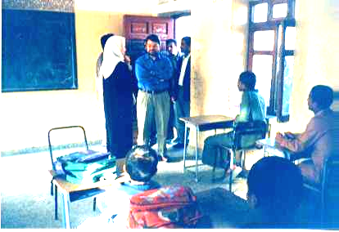
Mr. P. Zafiris Tzannatos (Sector Manager - Social Protection-Middle East and North Africa Region) visiting Social Care Center, one of SFD sub-projects - Sana’a City
Social Fund for Development Newsletter
30 Al-Kuds ST.
P.O. Box 15485
Sana’a, Republic of Yemen
Tel.: (967-1) 240417
Fax: (967-1) 243173
E-Mail: sfd1@y.net.ye

The course was attended by twenty trainees occupying senior positions in twenty women associations and centers in Sana’a City and Sana’a Governorate. Their work includes supervising the financial and accounting operations of their respective organizations. Before the course was held a training manual in accounting was prepared. This manual will be developed and improved further during the series of accounting courses that will be held in the future for the various associations and NGOs all over the country.

Achievements of the Fourth Quarter of 1999
The Size of Investment:
The SFD has contracted 161 new projects during the fourth quarter of 1999. They were allocated for all the governorates with a total investment of about 12 million dollars. In comparison, the number of projects in the first, second, and third quarters of 1999 were respectively 32, 80, and 101, costing $1,559,195 , $3,243,754 , and $5,126,437.
The following table shows that with regard to the size of investments Aden Governorate came first with 20% of the total, followed by Sana’a City and Sana’a Governorate.
Regarding the investment distribution by sector, education leads both in investment (35%) and number of projects (47%). The Social Services sector follows with 22% of the total investment.

Investment by Governorate (4th quarter/ 1999)
Percentage | Commitment ($) | No. of Projects | اGovernates
13 | 1,596,220 | 14 | ٍsana’a City
13 | 1,519,936 | 30 | ٍsana’a
20 | 2,412,874 | 11 | Aden
5 | 562,791 | 13 | Taiz
3 | 398,331 | 9 | Hodeidah
2 | 269,012 | 4 | Lahj
6 | 669,890 | 11 | Ibb
2 | 199,614 | 3 | Abyan
12 | 1,420,300 | 18 | Dhamar
4 | 492,453 | 7 | Hajja
5 | 621,985 | 7 | Baidhaa
2 | 203,091 | 3 | Sa’ada
9 | 1,098,301 | 8 | Mahweet
0.5 | 54,781 | 2 | Mareb
3 | 309,672 | 6 | Shabwa
1 | 151,031 | 6 | Hadhramout
2 | 195,395 | 4 | Al-Jawf
0.3 | 44,145 | 1 | Maharah
0.5 | 26,092 | 4 | More Gov.
100 | 12,245,914 | 161 | Total

The Managing Director of the W.B. Visit to the SFD

On the 25th of November 1999, the World Bank Managing Director – Corporate Secretary, Mr. S. Zhang and Mr. G. Brizzi, the World Bank Resident Representative in Sana’a, paid a visit to the SFD. During the visit, the SFD Managing Director, Mr. A. Al-Arhabi, gave a brief presentation about the SFD current activities and past achievements. Mr. S. Zhang expressed his satisfaction for the SFD good work and wished for the SFD staff more success.

From the right: Mr. S. Zhang , Mr. G. Brizzi during the visit.

SFD Staff Periodic Meeting

The SFD staff periodic meeting was held on the 4th of December 1999. The meeting concentrated on discussing the findings of the Midterm-Review Mission. An in-depth discussion regarding the SFD’s role in helping reduce poverty in Yemen took place. The role through the development of community assets and services, small and micro-enterprises, and institutional capacity building, was reviewed. The meeting also covered various topics such as targeting, social impact, community involvement, inclusion of marginalized communities, demand-driven approach, transparency,
sustainability,
and monitoring
and impact
evaluation.
The meeting
illustrated
the SFD
achievements
in terms of
the number
of projects,
number of
beneficiaries,
and number
of job opportunities created. The achievements made have by far exceeded the original appraisal estimation. The SFD Managing Director stressed the need for more creative and innovative approaches and technical solutions.
After the periodic meeting, two separate meetings were held and attended by the Planning and Monitoring Unit staff, heads of units, and heads of branch offices. During these two meetings, each branch presented its progress in the 1999 plan and the plan for the year 2000.

How Many Languages are Spoken by SFD Staff?
One of the SFD characteristics is the recruitment of talented employees with diversified educational backgrounds. Most of the SFD staff is fluent in one or more foreign languages such as English, German, Italian, Spanish, French, Russian, Romanian, Chinese, Urdu, Hungarian, Bulgarian, Amharic, Polish, Sidamo, and Serbo-Croatian.
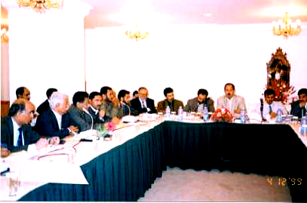
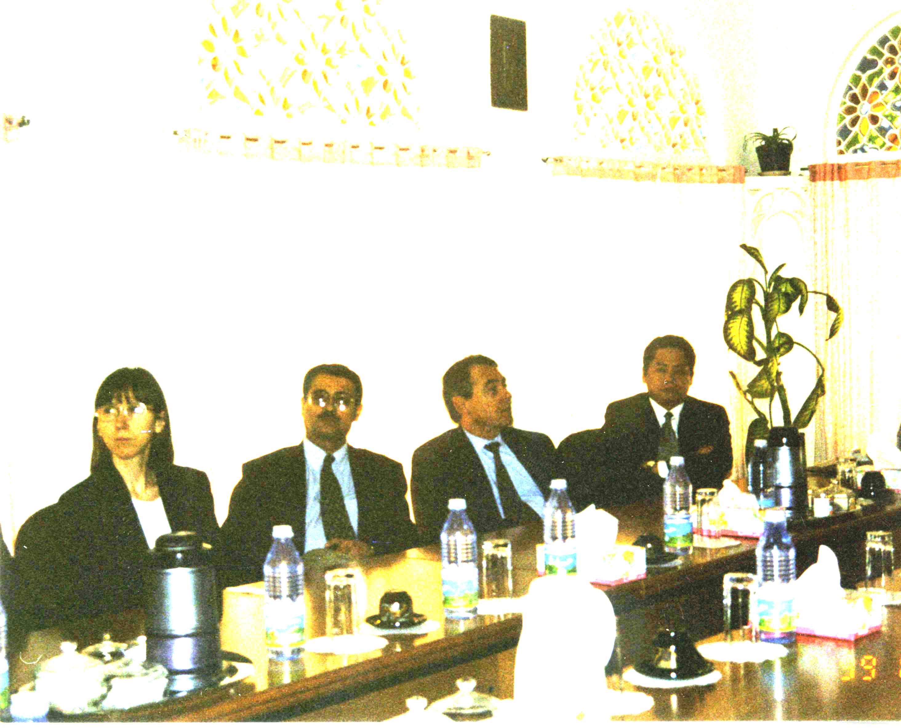
The loan capital and its purpose differ from one project to another. While the use of the loan is specified in the Marawe’ah and Darjaj programs, the Hodeidah MF Program gives loans for any purpose. Also, collateral requirements can be different: personal or group guaranties, mortgages, …etc. The loan capital can range from a few thousands Rials to more than YR 100,000. While Aden and Hais programs target only women, all other programs target both sexes. The percentage of women in these programs varies from 1% to 61%.
From the establishment of the SMED Unit until Dec. 99 the cumulative amount of loans was over YR 281,000,000.

Community Development Program News
Training Courses in Water Harvesting Schemes:
During the period of 5-7/10/99 a training course in water harvesting was conducted for 17 consultants and a female consultant. In the first day of the course the SFD Water Harvesting Program, its goals, past achievements, mechanism of implementation, were presented and discussed. A completed project was presented as an example. During the second and the third day a visit to the district of Arhab in Sana'a Governorate was made with the purpose of examining some of the cisterns in need of rehabilitation.

Basic Education Program:
During the period of 21-27 of November 1999, Dr. M. Hashem, a consultant specialized in education and development, conducted an identification visit with the goal of establishing a plan for the Basic Education Program, and the Rural Girls' Education Program. These programs will target districts that have low enrollment rates for basic education.

Capacity Building Program News
The First Training course in the Basics of Financial and Accounting Systems:
The SFD has financed the first course in the basics of financial and accounting systems for associations and NGOs that took place in Sana’a from the 20th of November till the 2nd of December 1999.

Small and Micro Enterprise Program News

Some of the Activities Carried Out:
- The SFD Board of Directors has approved the SMED operations manual in its meeting of Dec. 12, 1999.
- The study of a new micro finance project in Hadhramout was completed, however, the NGO involved asked to delay the signing of the contract until the end of January 2000.
- A two-day workshop (22-23/12/99) on financial management was held for the SMED unit staff. The unit consultant presented useful exercises on financial management of micro-credit programs.
- Initial steps were taken to start a new project in the city of Taiz. During the initial appraisal visit contacts were established with the Tadhamon Islamic Bank, which showed interest to cooperate with SFD in micro finance.
- In November a training course was held for the accountants of all the SMED programs as part of its strategy to develop an accounting system for its programs. The course covered the basic principles of accounting. A follow up course will be held on the first quarter of 2000.
- Professor Harper, a specialist in micro finance carried an advisory mission for the SFD from 20-29/11/99. He visited some of the SMED programs, and provided valuable recommendations to further ensure their sustainability.

Projects News:
Mid-Term Evaluation of Hodeidah MF Program:
A team of MF specialists and the project officer have carried out an evaluation of the Hodeidah MF Program. The results showed that the program has made a good progress in delivering its services and in developing an effective management system. The mission recommended that the program should concentrate more efforts on loan arrears to ensure effectiveness and sustainability.

Increase in the demand for loans:
During the last quarter of ‘99 the demand for loans has increased in all projects. This increase resulted from the harvesting of crops, the increase in livestock prices, and the start of Ramadan, a period in which markets are more active. At the end of Dec. ‘99 the total outstanding portfolio was over 118.6 million YR, and the number of loans was 3888.
The following table shows the financial details of the programs.
Program | Active No. of Borrowers | Active No. of Savers | Outstanding Loan Portfolio (YR) | Repayment Rate
Hodeidah MF | 1,951 | 0 | 59,006,278 | 98%
LSED- Hais | 337 | 1,074 | 7,365,445 | 93%
Seih MC | 229 | 0 | 4,551,280 | 95%
Women S&C- Aden | 18 | 491 | 173,000 | -
Marawe’ah IGP | 471 | 0 | 18,998,150 | 98%
Darjaj IGP | 414 | 0 | 14,776,246 | -
Beekeeping- Odain | 31 | 0 | 1,428,900 | -
Wadi Mor IGP | 368 | 0 | 9,554,738 | -
Jabal Habashi IGP | 69 | 0 | 2,800,679 | -
Total | 3,888 | 1,565 | 118,654,716 | -

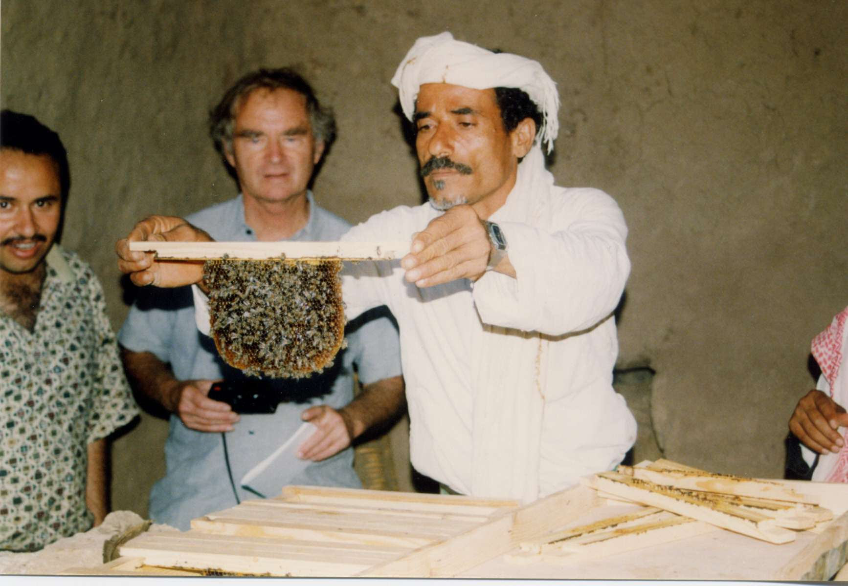
Professor Harper visiting the Bee keeping and Honey Production Program in Odain -Ibb
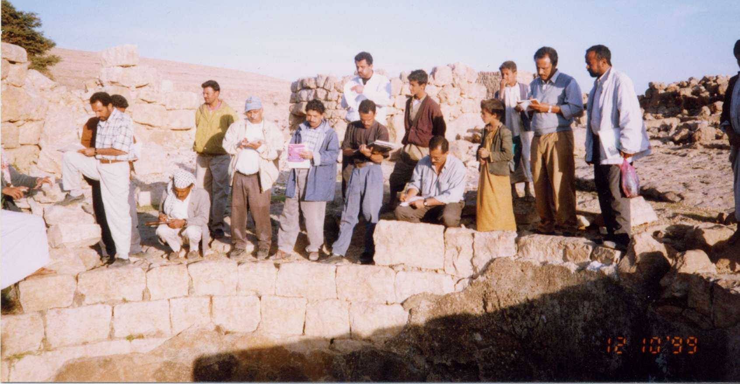
The consultants visiting water cistern -Sana’a Governorate
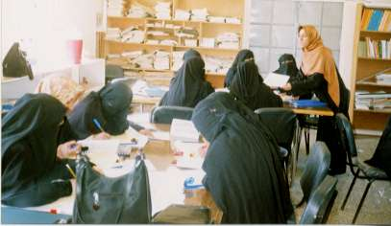
The trainees during the course for basic financial and accounting systems

